# Login Feature of Flipkart App

## Pre-requisites

During the First opening:

Click > Allow Only while using the app

Click > English

Enter > Mobile Number

Click > Continue

Wait > For OTP

Wait > Automatically fills the OTP

Click > Select any three Categories to see best deals

Click > Continue to Flipkart

Click > Account among Home, Play, Categories, Account and Cart at footer section

Make > Logout, If logged in

### Login Button:

Fig: 1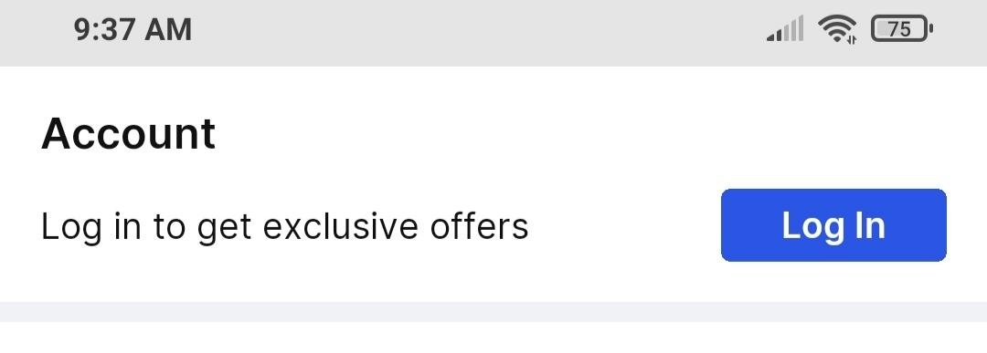

After clicking Login Button

Fig: 2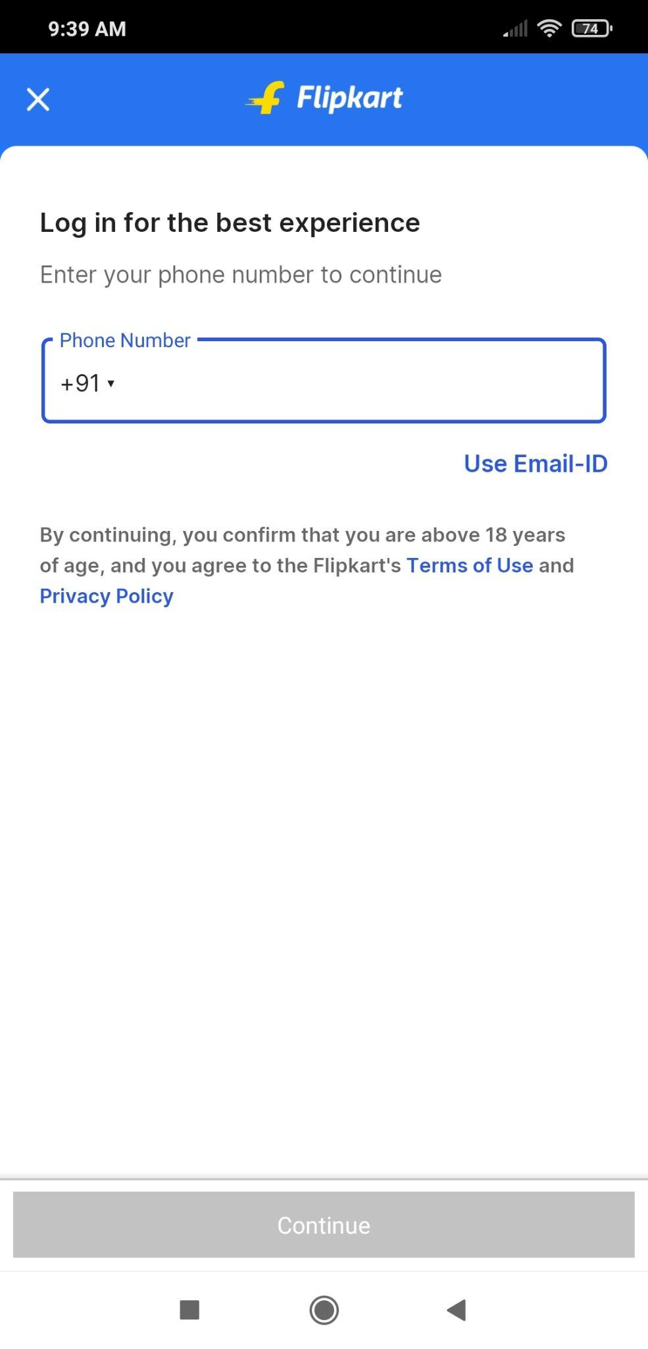

## Equivalence Partitioning

After clicking The input box

Fig: 3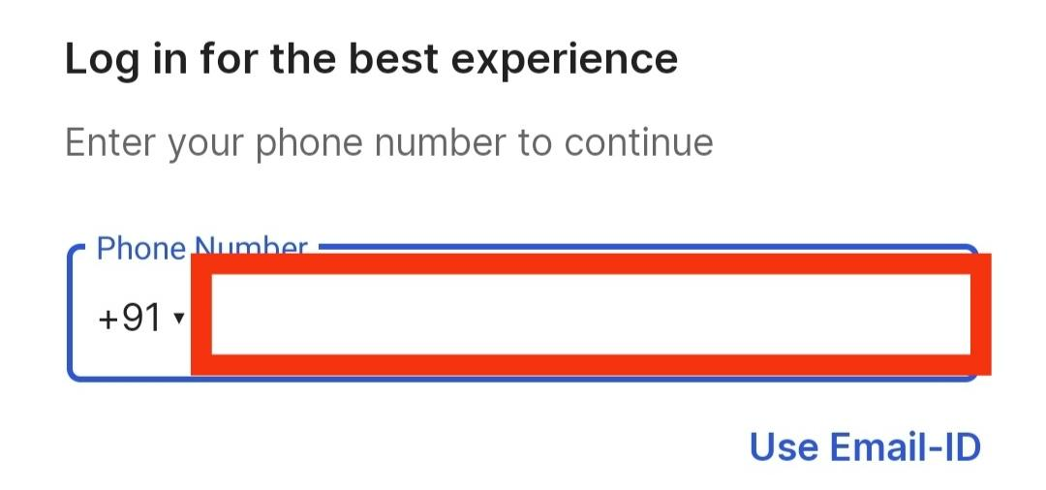

Shows a number pad Meaning only numbers can be provided.

### Using Phone number

| Test Case ID | Phone Number Length | Continue button(Is Active) |
| --- | --- | --- |
| TC_0001 | 1 to 9 | Inactive |
| TC_0002 | 10 to 15 | Active |
| TC_0003 | 16 to - | Inactive |

### Using Email-ID

Pre-requisites: Click on Use Email-ID

Fig: 4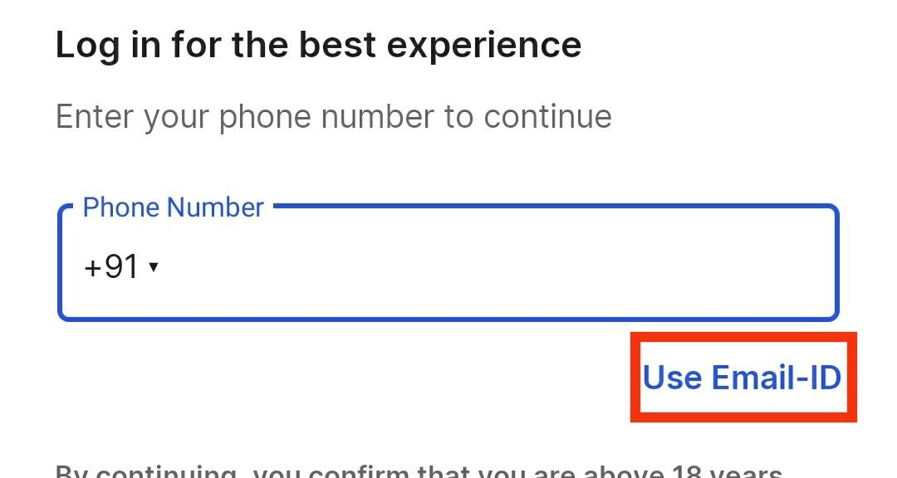

#### 

#### 

#### 

#### 

#### For the Email syntax: [*@*.*]:

Where * before @ is said as first star.

* after @ said as second star.

* after . said as third star.

#### Test for all three stars to be String type:

| Test Case ID | Length of String at * | Continue button(Is Active) | Image |
| --- | --- | --- | --- |
| TC_0004 | 1 | Active | Fig: 5 |
| TC_0005 | 2 | Active | Fig: 6 |
| TC_0006 | 10 | Active | Fig: 7 |

## Boundary Value Analysis

### Using Phone number

Valid Range: 10 to 15.

Invalid Range: 0 to 9, and 16 and above.

| Test Case ID | Phone Number Length | Continue button(Is Active) | Image |
| --- | --- | --- | --- |
| TC_0007 | 9 | Inactive | Fig: 8 |
| TC_0008 | 10 | Active | Fig: 9 |
| TC_0009 | 11 | Active | Fig: 10 |
| TC_0010 | 14 | Active | Fig: 11 |
| TC_0011 | 15 | Active | Fig: 12 |
| TC_0012 | 16 | Inactive | Fig: 13 |

## Decision Table

### Using Phone number

Valid Range: 10 to 15.

Invalid Range: 0 to 9, and 16 and above.

| Test Case ID | Phone Number Length(>=10 and <=15) | Continue button(Is Active) |
| --- | --- | --- |
| TC_0013 | ✅ | Active |
| TC_0014 | ❌ | Inactive |

### Using E-Mail-ID

Syntax: #1@#2.#3

Where # is a text meaning it can be integer, String or symbols must not be kept empty most often.

Make sure @ must be before . to be active.

Conditions(n): 3 [#1(>0), #2(>0) and #3(>0)].

Ways: 2^(n) = 2^(3) = 8 ways or conditions.

| Test Case ID | #1(>0) | #2(>0) | #3(>0) | Continue button(Is Active) | Image |
| --- | --- | --- | --- | --- | --- |
| TC_0015 | ❌ | ❌ | ❌ | Inactive | Fig: 14 |
| TC_0016 | ❌ | ❌ | ✅ | Inactive | Fig: 15 |
| TC_0017 | ❌ | ✅ | ❌ | Inactive | Fig: 16 |
| TC_0018 | ❌ | ✅ | ✅ | Inactive | Fig: 17 |
| TC_0019 | ✅ | ❌ | ❌ | Inactive | Fig: 18 |
| TC_0020 | ✅ | ❌ | ✅ | Inactive | Fig: 19 |
| TC_0021 | ✅ | ✅ | ❌ | Inactive | Fig: 20 |
| TC_0022 | ✅ | ✅ | ✅ | Active | Fig: 21 |

### 